PIZZA SALES SQL QUERIES

**A.KPI'S**

1- TOTAL REVENUE:

SELECT SUM(total_price) as Total_Revenue FROM pizza_sales;

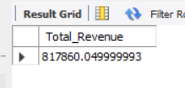

2- AVERAGE ORDER VALUE:

SELECT SUM(total_price)/count(distinct order_id) as Average_Order_Value FROM pizza_sales;

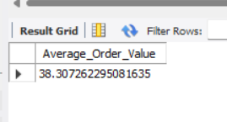

3- TOTAL PIZZA SOLD:

SELECT SUM(quantity) as Total_Pizza_Sold FROM pizza_sales;

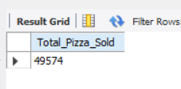

4- TOTAL ORDER:

SELECT count(distinct order_id) as Total_Order FROM pizza_sales;

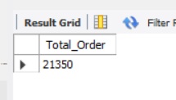

5- AVERAGE PIZZAS PER ORDER:

SELECT round(round(sum(quantity), 2)/round (count(distinct order_id), 2),2) as Average_Pizzas_per_Order

FROM pizza_sales;

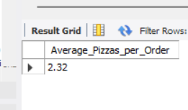

B:-DAILY TREND FOR TOTAL ORDERS:

SELECT dayname(order_date) as Order_Day, count(distinct order_id) as Total_Order

FROM pizza_sales

group by Order_Day;

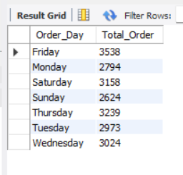

C:- MONTHLY TREND FOR ORDERS:

SELECT monthname(order_date) as Month_Name, count(distinct order_id) as Total_Orders

FROM pizza_sales

group by Month_Name;

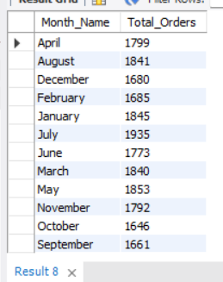

D:- % OF SALES BY PIZZA CATEGORY:

SELECT pizza_category,round(sum(total_price), 2) as Total_Revenue,

round(sum(total_price)*100/(select sum(total_price) from pizza_sales), 2) as PCT

FROM pizza_sales

group by pizza_category;

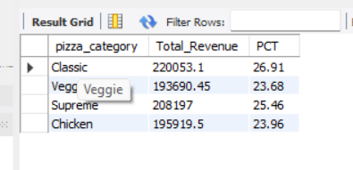

E:- % OF SALES BY PIZZA CATEGORY:

SELECT pizza_size,round(sum(total_price),2) as Total_Revenue,

round((sum(total_price)*100/(select sum(total_price) from pizza_sales)),2) as PCT

FROM pizza_sales

group by pizza_size;

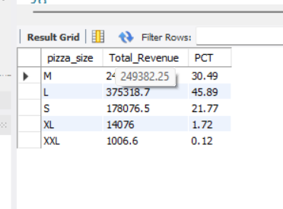

F:- TOTAL PIZZAS SOLD BY PIZZA CATEGORY:

SELECT pizza_category, sum(quantity) as Total_Quantity_Sold FROM pizza_sales

where month(order_date)=2

group by pizza_category

order by Total_Quantity_Sold desc;

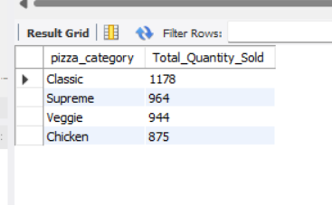

G:- TOP 5 PIZZAS BY REVENUE:

SELECT pizza_name, sum(total_price) as Total_Revenue FROM pizza_sales

group by pizza_name

order by Total_Revenue desc

limit 5;

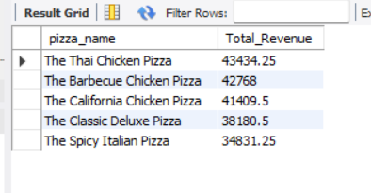

H:- BOTTOM 5 PIZZAS BY REVENUE:

SELECT pizza_name, round(sum(total_price), 2) as Total_Revenue FROM pizza_sales

group by pizza_name

order by Total_Revenue asc

limit 5;

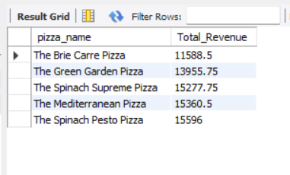

I:- TOP 5 PIZZAS BY QUANTITY:

SELECT pizza_name, sum(quantity) as Total_Pizza_Sold FROM pizza_sales

group by pizza_name

order by Total_Pizza_Sold desc

limit 5;

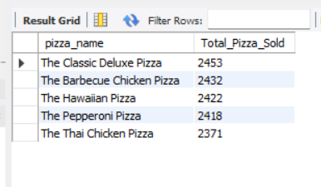

J:- BOTTOM 5 PIZZAS BY QUANTITY:

SELECT pizza_name, sum(quantity) as Total_Pizza_Sold FROM pizza_sales

group by pizza_name

order by Total_Pizza_Sold asc

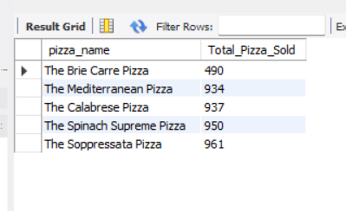limit 5;

K:- TOP 5 PIZZAS BY TOTAL ORDERS:

SELECT pizza_name, COUNT( distinct order_id) as Total_Orders FROM pizza_sales

group by pizza_name

order by Total_Orders desc

limit 5;

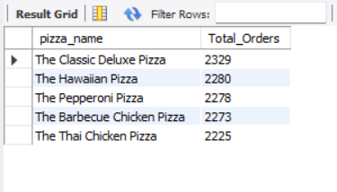

L:- BOTTOM 5 PIZZAS BY TOTAL ORDERS:

SELECT pizza_name, COUNT( distinct order_id) as Total_Orders FROM pizza_sales

group by pizza_name

order by Total_Orders asc

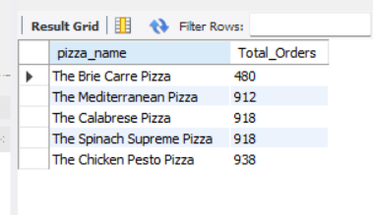limit 5;